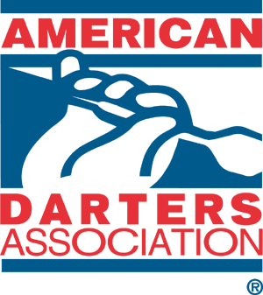

Meeting Outline

- Welcome, ADA Orientation Meeting & Tournament My name is ________ Representative for the ADA
- Purpose of the event is to introduce the ADA and develop an American Dart League for greater ___________ area
- Thank the bar for hosting this event.
- Special guests, your Management Team, Division Reps and Pro’s in attendance
- Reminder registration for the draw doubles tournament is $10.00 see my assistant (_________). Tournament begins immediately following the Orientation Meeting
- Randomly draw a prize. Let them know about the additional ticket for “sampling” (where applicable)
- Go over American Dart League formats
  - Express: three-person teams; Team League 4-6 members; Doubles Format 2 members, Singles Format, 1 member.
  - Minimum four-teams required to start/6 for Singles League
  - $20. Annual membership fee through PayPal.
  - League dues are $10 per member per week/$14 for singles
  - League Weeks in a season based on number of teams
  - Top 4-teams make the playoffs.
  - Awards first place plaques for each member, pins for 180, 9-mark & hat tricks. $2.00 awarded for each win with bonus money in the Finals.
  - Number of Games per format: Doubles – 11 games; Express 8 games with a bonus point; Team – 12 games with a bonus point; Singles 11 games
  - There will be an appointed Division Rep to oversee each division. Scores are collected through a variety of options based on the location
- ADA American Dart League member benefits:
  - Digital ADA Membership
  - Member of the Week & Month awards
  - Most Valuable Player at the end of each session
  - All members eligible for the ADA Championship Series
  - ADA National Championship moves all over the country each year!
- League night, ________. League begins as soon as minimum four-teams register:
https://www.adadarters.com/adl-team-roster-form/
- Weekly standings posted weekly on ADA web site: www.adadarters.com

