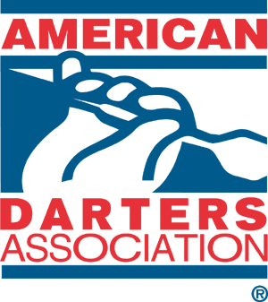
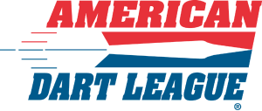

Making Your ADL Business Successful
Planning/Marketing

1. Develop a weekly three-hour sales plan:
+ Before you go out blindly, utilize Google and do a search for Bars & Locations within a 15-mile radius. Example: https://www.google.com/search?q=Bars+and+Taverns+in+Wake+County+NC&oq=Bars+and+Taverns+in+Wake+County+NC&aqs=chrome..69i57j0i512j0i22i30l8.13407j0j4&sourceid=chrome&ie=UTF-8 Find out which locations have darts/will have darts/etc.
+ Put together a “sales kit”. This includes all marketing materials for your area(s):
~ ADL Business Cards, Flyers, Posters, Location Window Cling for front door/window, cell phone for taking pics and promoting the location on social media
+ First Impressions! Walk in with either your ADA or ADL Apparel representing your new business and brand! For additional ADL Apparel: https://www.adadarters.com/ada-apparel-2/#!/all
+ Where did you go this week: https://www.adadarters.com/american-dart-league-sales-form-link/ (filling out this link each week gets you additional Rep Reward Points): https://www.adadarters.com/2022-ada-rep-reward-page/ - You will also get a generated email back on which locations you have been too for your notes to review.
+ You’ll want this sales period to be the same each week and consistent. Fit this time frame into your schedule
2. Create a Social Media Account: Facebook, Twitter and Instagram are the three that the Home Office uses. Title each/all Social Media platforms with: American Dart League of __________
To save time and money, you can sign up with a program called MailChimp This sends out to all three Social Media outlets listed in this paragraph at the same time.

3. Follow up is just as important as the initial sales stop. Now-a-days locations are just as hungry as we are for leagues and guaranteed traffic.

Directing/Management Team
1. You are the Management Owner/ADA Representative. A business cannot be ran by one person and one person alone.
+ Once you have established some leagues and events, you will want to start looking for a right-hand person, known as your: League Manager. This person will oversee all leagues running.
+ Same goes for a Sales Manager. Once properly trained, this person will take over your 3-hour sales period each week.
+ Division Rep’s for every division running is key! These members will be on the front line each week overseeing the league, the members, collecting league dues, etc.
For each person above on your new Management Team, do you/would you like the following for them:
A. ADA/ADL/apparel to wear as uniform each time they play/run the division
B. Business Cards to give interested locations and players that they may run into
C. Stay in contact with them each week division play is going
D. Take care of your Division Reps each year
+ Does your Division Reps stay in contact with their Team Captains and answer any and all questions that come to them

American Dart League Divisions Net Per Team
1. What is your Net Per Team
+ How much money are you making per division?
+ What are your expenses?
+ Are you setting aside monies for: Bonus Money, Nationals/Regional Travel Fund/etc.
2. Forward me your Net Per Team. If you need assistance, please contact me

ADA/ADL Local Events/Promotions/Meetings/ADA Tournaments
1. Have Team Captains each Season/session. These can also be tied into your Tournament Orientation Nights.
2. Have Orientation Meeting/Tournaments for each new division/new members. Historically, ADA Reps who utilize this additional event recruit more league members for divisions.
3. ADA Members only Tournaments/membership drivers. This increases brand awareness and gives our ADA Members an additional benefit for playing with us!
Pro’s/Open League(s)/ADA Pro Tours
1. Advertise and Promote Open Format League(s)
+ Have members ‘graduate’ in the Neutralizer league and move to the Open Format Leagues. Then they can level up one more and try for Professional Status
2. After you establish ADA Professional Members, you can do Pro Bounties/Challenge the Pro!

Goals
1. What are you team count goals
2. How many teams/members do you want this season/session?
How can we make your business grow?

