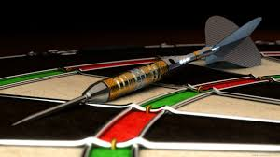

|  |  |
| --- | --- |
| |  | | --- | | **Come join the ADA!** ***The United States’ Largest Soft Tip & Steel Tip Organization.***  **Become a Member to take advantage of numerous ADA Benefits**:  **-Receive a personalized Digital Membership card that allows you access to everything the ADA has to offer!**  **-Members can create their very own ADA Darter Profile on the ADA website!**  **This will allow you to update your info, stay informed of upcoming events and leagues, earn rewards and discounts, track your stats with the ADA, and more!**  **-Local & National Rankings in all dart types with prizes and awards.  - Prize $$$ based on wins and playoffs paid back at the end of each session. -Gain a chance to participate in annual Regional & National Championships with over $70,000 in payouts!!!**  **In-house and online leagues starting all over the country! Contact your local League Representative today!**    **ALL SKILL LEVELS CAN PLAY & WIN!**  ***When you’re having fun, everyone wins! The American Darters Association provides a fun, friendly atmosphere; while letting Members choose from casual and competitive formats.***  **-Our Neutralizer average handicapping system allows beginner, novice, and established players to compete with each other in a more fairly matched setting.**  **-Non-handicapped, Open format available, with the slightly more experienced player in mind.** | |

**Annual Membership cost is only $20**

**Contact ADA Area ____, _____________, for more information. (636) 614-4380 OR fname@adadarters.com**