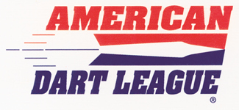
Karl Remick
ADA Rep
636.614.4380 x 1001
kremick@adadarters.com

HOST LOCATION TOURNAMENT SPONSORSHIP FORM

Location: Final Destination
Address: 10660 Saint Charles Rock Rd
City: Saint Ann St: MO Zip:
Phone: (314) 423-1100
Event: ADL Orientation Tournament Sunday, February 18th 2:00pm

I, ____________________________________ agree to sponsor the tournament ran by the American Dart League (ADL) out of this location above and agree to support the tournament staff with the items below.

I agree to the sponsorship and support the event as follows:

+$250 Sponsorship for the event (percentage of the monies will be given back to the players in attendance; $50 will be towards the Nationals Travel fund)
+Food and drink specials for the participants
+$50 bar tab for the one/two event directors
Tournament Event is pending until this document is filled out, fee paid signed and returned back to the American Dart League Home office.

Owner/Manager_____________________________________
Date__________

Thank you, for your sponsorship!
American Dart League
PO Box 627
Wentzville, MO 63385
636-673-1092

