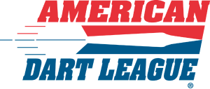

HOST LOCATION TEAM SPONSORSHIP FORM

Location: _________________________
Address: _________________________
City: _____________________ State: _____ Zip: ________
Phone: ___________________________

I, ____________________________________ agree to sponsor the team(s) in the American Dart League (ADL) for each session they would like to play out of this host location.

I agree to the sponsorship fee is as follows:
Doubles League: $4.50 per team per week of regular session play
Express League: $4.50 per team per week of regular session play
Team League: $5.50 per team per week of regular session play

Invoices will be sent as needed. Sponsor fees must be paid on or before the second week of the ADL session. Checks should be made payable to the “American Dart League”. A $35.00 return check fee will be incurred for any return check.

I understand that all teams must abide by the American Darters Association League rules and those of the local ADL By-Laws. The age requirement for the ADA/ADL is 18 years of age. Allowing persons under the age of 21 to play in the league is set forth by the locations/owners rules and regulations. By signing this document you are allowing 18 year olds to come into your establishment for ADL league play and will not hold the American Dart League or American Darters Association responsible.

Owner/Manager_____________________________________
Date__________
Thank you, for your sponsorship!
American Dart League
PO Box 627
Wentzville, MO 63385
636-673-1092

