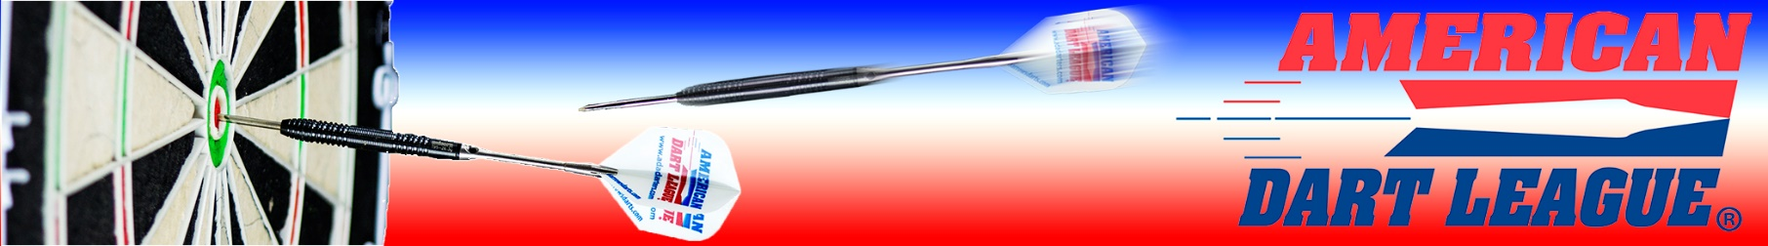

Soft Tip Orientation Blind Draw

Monday, February 19th

Sign up @ 7pm, Start at 7:30

Soft Tip Open Doubles League will start the following Monday.

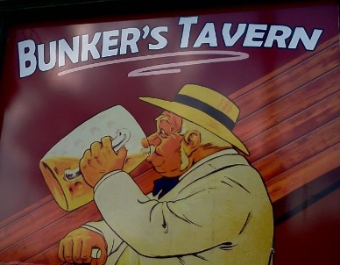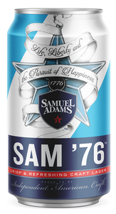

297 Saint Francois St., Florissant, MO

(314) 8372601 Find them on Facebook too!



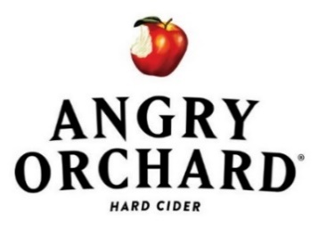



Accepting teams for doubles league

Membership & league sign-up NOT required to play in the Blind Draw

Blind Draw is 100% payback, $10 to enter.

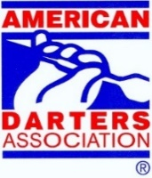Cricket & 501, Draw your partner



$MONEY ADDED to the draw$

For more info, contact ADA Representative Chris Stone:

636.614.4380 x 1004 or email:[cstone@adadarters.com](mailto:cstone@adadarters.com)